# 02. Delivery Boy

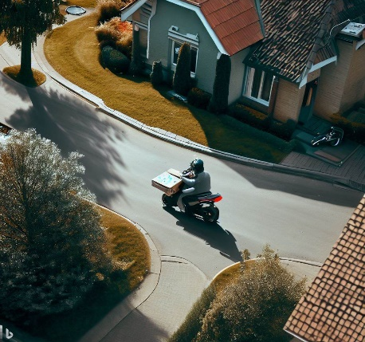

*Today, we have an exciting programming task that will take you on a pizza delivery adventure in a neighborhood represented by a matrix. Get ready to navigate a delivery boy through the streets, avoid obstacles, and make timely pizza deliveries!*

You are a pizza delivery boy with a motorized vehicle that delivers pizza in a neighborhood. The neighborhood is represented by a matrix - **field**. **Each cell** in the field represents a **part of the neighborhood**, and it **can contain one of the following elements**:

* **'B'** - Represents the **starting position** of the delivery boy.
* **'A'** - Represents an address where a pizza needs to be delivered.
* **'*'** - Represents an **obstacle** or an area where the delivery boy **cannot drive**.
* **'P'** - Represents the pizza restaurant.
* **'-'** - Represents the road, the **delivery boy can drive over it**.

In the beginning, you will be given **N** and **M** – **integers, separated by a single space - " "**, indicating the **field’s dimensions.** On the next **N** lines, you will receive strings, representing the **rows** of the area, with **M** columns. You must **keep data for the initial position of the delivery boy** as **you will need it later for the final output**.

The delivery boy must carefully navigate through the streets, following the commands that will be received on each of the following lines- **"up", "down", "right",** and **"left"**, moving one position at a time. **Each step he takes**, **the '-'(dash) cells he passes (road) through become '.' (dot) to indicate his path**. However, the **roads may cross**, and the boy **can ride over the same road again and again**. That means the boy **can** **drive over** **'.'-cell also.**

In this pizza delivery adventure, the delivery boy **starts his journey from the position marked as 'B'** on the neighborhood **field**. His **first task** is to make his way to the **pizza restaurant marked as 'P'** and collect the delicious pizza. Once he collects the pizza, **the position 'P' is marked as 'R'** and a **message is displayed on the Console**: **"Pizza is collected. 10 minutes for delivery."**

However, the neighborhood is not without **obstacles**. Whenever the delivery boy encounters a **cell marked with '*'**, it signifies an obstacle, and he **cannot make a move in that direction**. He must **remain in his current position** and find an alternative route. The delivery boy should **wait for the next command**.

**If**, at any point during his journey, **the delivery boy steps out of the neighborhood field** (matrix boundaries), it means he has ventured **beyond the streets of the neighborhood**. In such a case, the delivery boy will be considered **late for the delivery**, and unfortunately, **the delivery will be canceled**. The following **message should be displayed on the Console**: **"The delivery is late. Order is canceled."**

The delivery boy will **always collect the pizza** ('P'), **before heading to the address,** marked as 'A', ensuring a successful delivery.

Once the delivery boy successfully reaches an **address marked as 'A'**, he joyfully delivers the pizza, **completing his mission**. **The position 'A' is marked as 'P'.** A message will be displayed on the Console: **"Pizza is delivered on time! Next order..."**

Remember, the delivery boy must follow the commands, avoid obstacles, and ensure timely pizza deliveries to the addresses. Good luck!

In the end, **print the final state of the matrix** (neighborhood area) with **the delivery boy in its starting position. If the boy has been out of the field, mark his starting position with an empty space**. **Each row is on a new line**.

## Input

* **On the first line,** you will get the **number of rows** and **columns of the matrix, separated by a single space**.
* On the next **N** lines, you will receive strings, representing each **row** of the matrix.
* On each of the following lines, you will receive the possible directions for the delivery boy to move - **"up", "down", "right",** and **"left"**.

## Output

* **On the first line:**
  + When the boy collects the pizza:

**"Pizza is collected. 10 minutes for delivery."**

* + If the pizza is delivered successfully:

**"Pizza is delivered on time! Next order..."**

* + If the boy leaves the field boundaries:

**"The delivery is late. Order is canceled."**

* On the next lines, print the **final state of the matrix** with **the delivery boy in its starting position**. **If the boy has been out of the field, mark his starting position with an empty space. Each row - on a new line**.

## Constraints

* The commands are guaranteed to lead him **either to a successful delivery** or **out of the field**, ensuring that the **commands are sufficient in all cases**.
* **Each row** of the matrix will have the **same length**.

## Examples

|  |  |  |
| --- | --- | --- |
| **Input** | **Output** | **Comments** |
| 5 6  *----A  *B***-  *-***-  *----P  ******  down  down  right  right  right  right  up  up  up | Pizza is collected. 10 minutes for delivery.  Pizza is delivered on time! Next order...  *----P  *B***.  *.***.  *....R  ****** | The boy moves down and the position is marked with **"-"**. He is driving on the road, so he expects the next command.  Next command is **"down"**, and the position is marked with **"-"**. The previous position is marked with **"."**, because you need to indicate the boy’s path.  The next command is **"right"**, and the position is marked with **"-"**. The previous position is marked with **"."** because you need to indicate the boy’s path.  Following the commands, the boy reaches the **"P"** position and collects the pizza. The position is marked with **"R"** as a restaurant. Do not forget to indicate the boy’s path.  Following the commands, the boy delivers the pizza successfully to the address - **"A"** and the address is marked with **"P"**.  The boy returns to his initial position but his path remains on the field. |
| 5 6  *----A  *B***-  *-***-  *----P  ******  down  down  left  right  right  right  right  right  up | Pizza is collected. 10 minutes for delivery.  The delivery is late. Order is canceled.  *----A  * ***-  *.***-  *....R  ****** |  |